ARMY PUBLIC SCHOOL SAMBA
WEEKLY REPORT
SEPTEMBER 11,2023 - SEPTEMBER 30,2023

SCHOOL EVENTS

INVESTITURE CEREMONY (SEPTEMBER 11,2023)
To inculcate the leadership qualities in students and to give them a feel of being an important and integral part of the administrative body, the Investiture Ceremony for the academic session 2023-24 was held on September 11,2023 with great pomp and dignity at Army Public School Samba.
It was the occasion where the young students were all prepared to don the mantle of leadership and discharge the responsibilities entrusted to them by the school. The event began with a march by the newly elected Prefects along with the House-Captains,Vice House Captains and other newly elected members.
The Principal,Mr Snjeev Pradhan pinned the badges and sashes to all the appointment holders and handed over the House flags to the House Captains,and school flag to the Head Boy and Head Girl and entrusted the responsibility to the newly elected office bearers to spread the light of knowledge and pass on the rich legacy of values of APS Samba to their juniors.
The Principal congratulated the newly appointed Cabinet members for their preparedness to take up responsibilities entrusted to them and motivated them to do as they say and say what they do.The programme concluded with the vote of thanks and singing of the School Anthem.

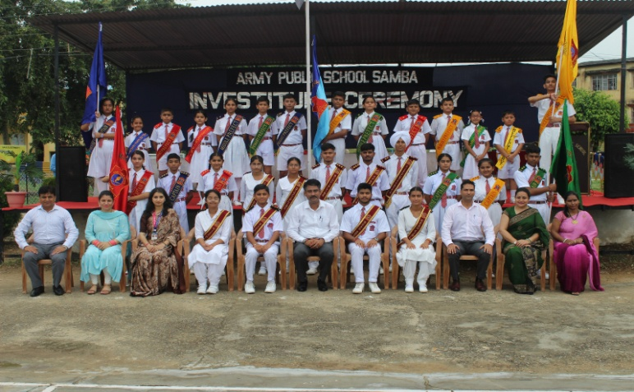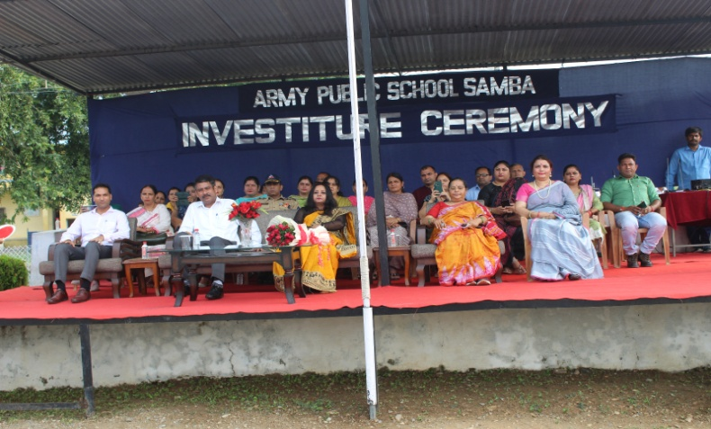
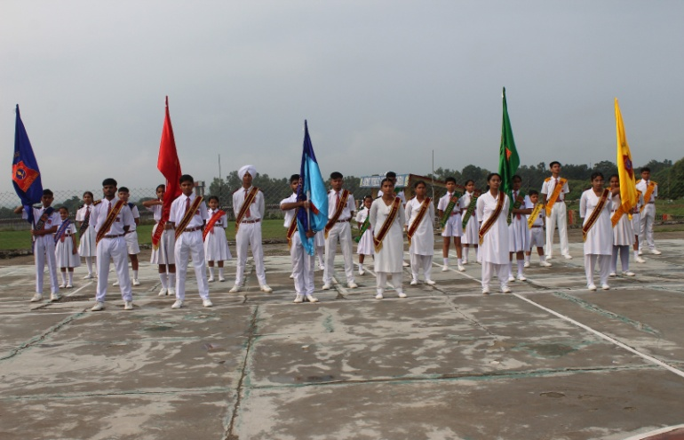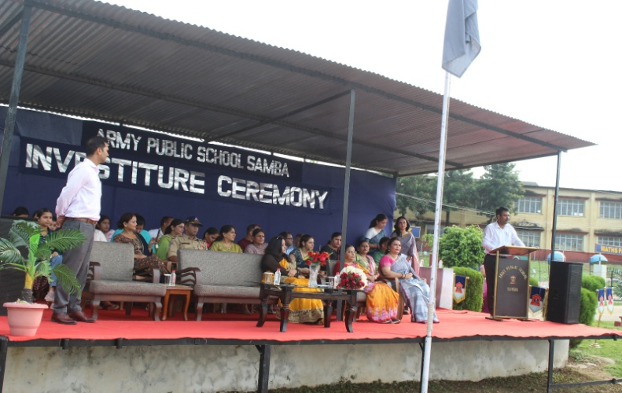

INTER SCHOOL DISTRICT LEVEL NET BALL COMPETITION (SEPTEMBER 12,2023)
An Inter School District Level Net Ball Competition was organized by the Department of Youth Services and Sports on September 12,2023 at Rani Suchet Stadium Samba. Students from APS Samba also participated in this competitionand 4 students in U-19 category and 7 students in U-14 category got selected for the next District Level competition.

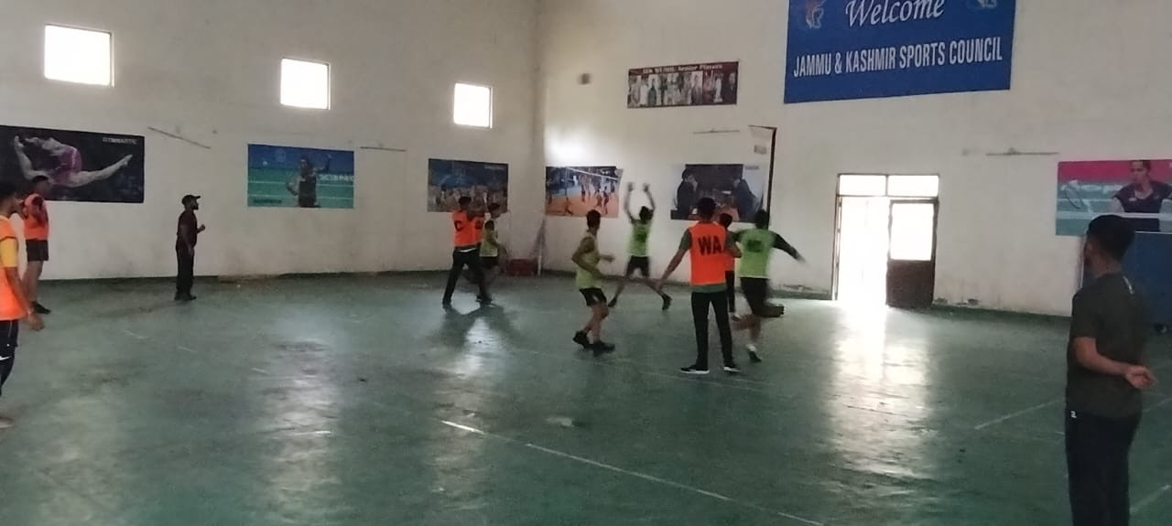

INTER ZONE DISTRICT LEVEL ATHELETICS COMPETITION (SEPTEMBER 19,2023)
An Inter Zone District Level Atheletics Competition was organized by the Department of Youth Services and Sports on September 19,2023 at Rani Suchet Stadium Samba. Students from APS Samba also participated in this competition.Two students: Rohit (XII) and Vansh(XI) were selected in SHORTPUT and 200 mtr race.

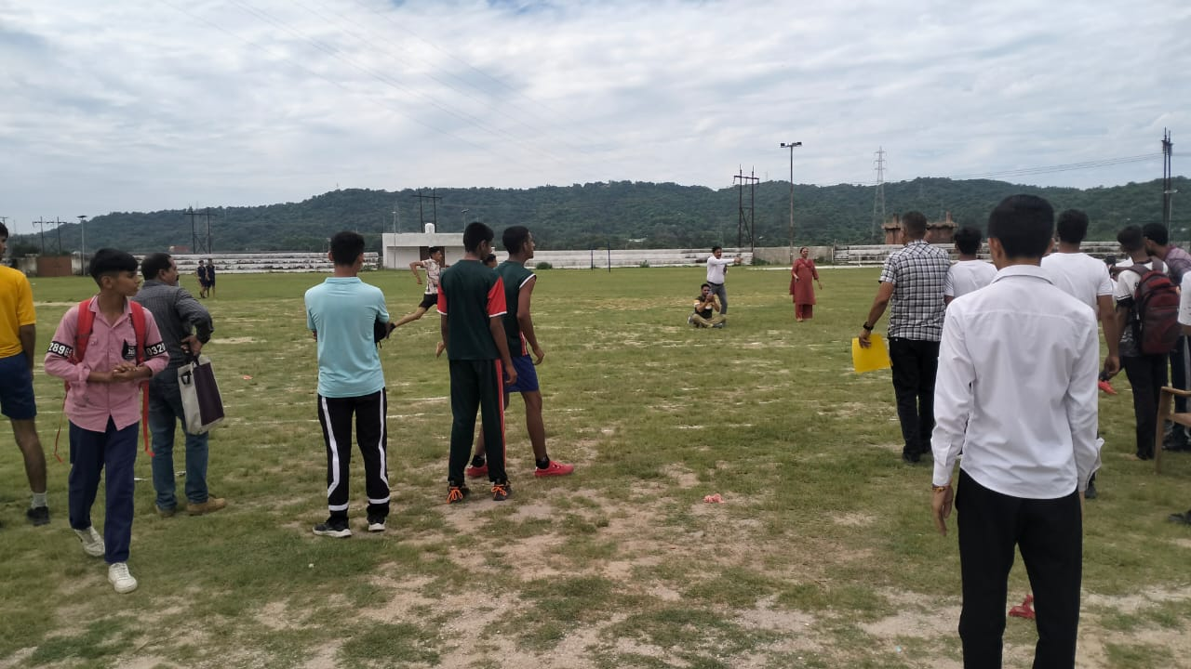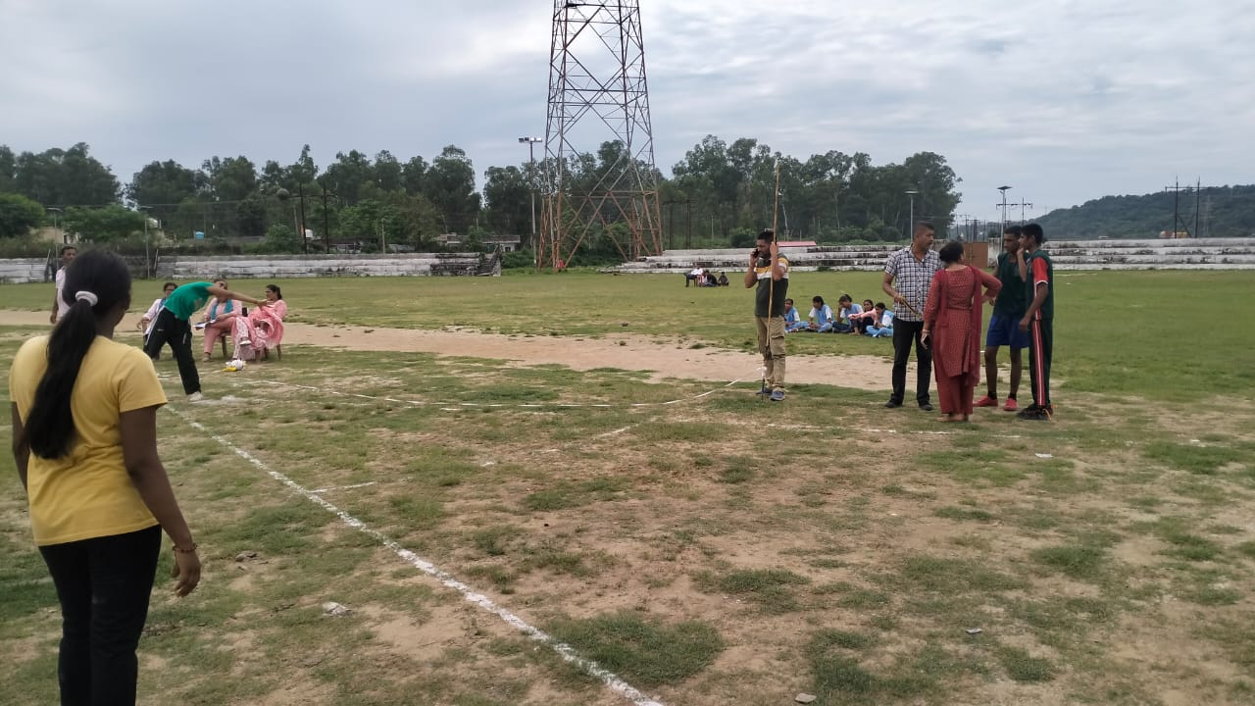

WEBINAR ON APS REPORT CARD FOR CLASSES I & II (SEPTEMBER 20,2023)

A webinar on APS Report Card for classes I & II was organized by FDRC, New Delhi on September 20,2023 from 1200 hrs to 1300 hrs. This webinar was attended by Ms Tania Sambyal,PGT English.

HALF YEARLY EXAMS FOR CLASSES III-X & XII (SEPTEMBER 14-30,2023)
Half Yearly exams for classes III-X and XII commenced at APS Samba from September 14,2023 to September 30,2023.

PROJECT VEER GATHA 3.0 (SEPTEMBER 15,2023)
Project Veer Gatha is an initiative of the Government of India to commemorate the bravery of Armed Forces of India.Students from APS Samba participated in various activities in this project.The one best entry from each category (3-5,6-8,9-10 and 11-12 )was uploaded on the government portal on September 15,2023 and students received e-certificates of participation.
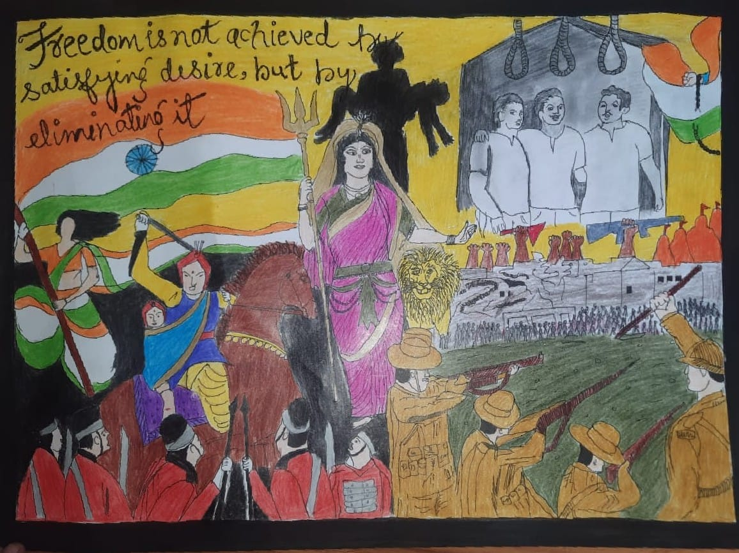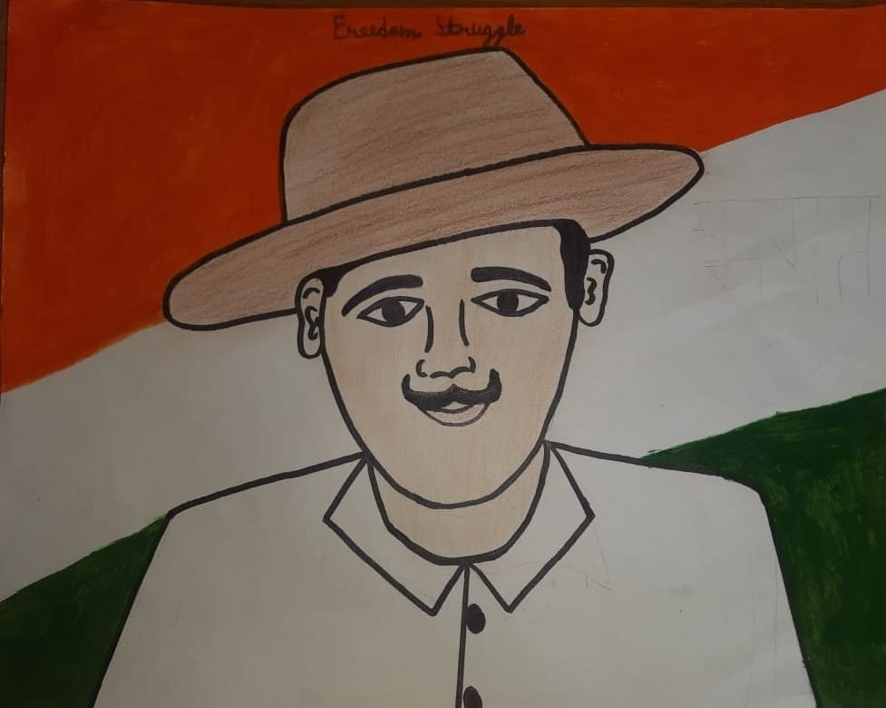
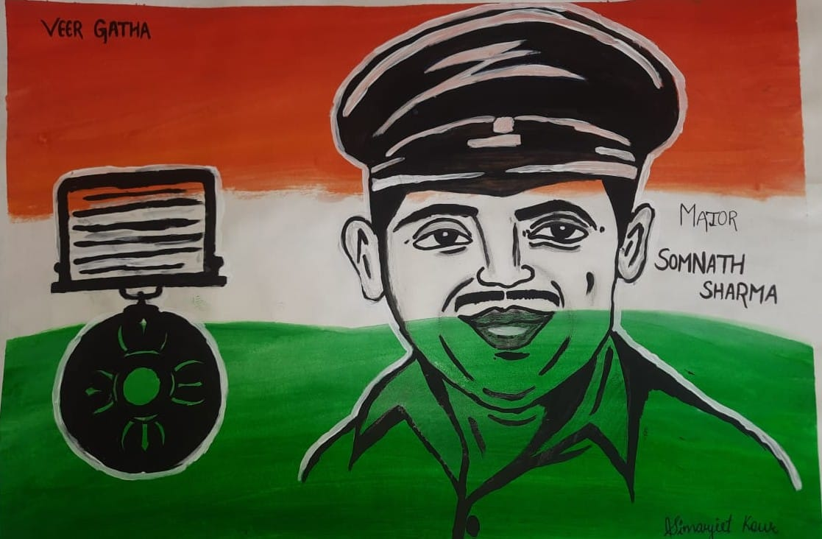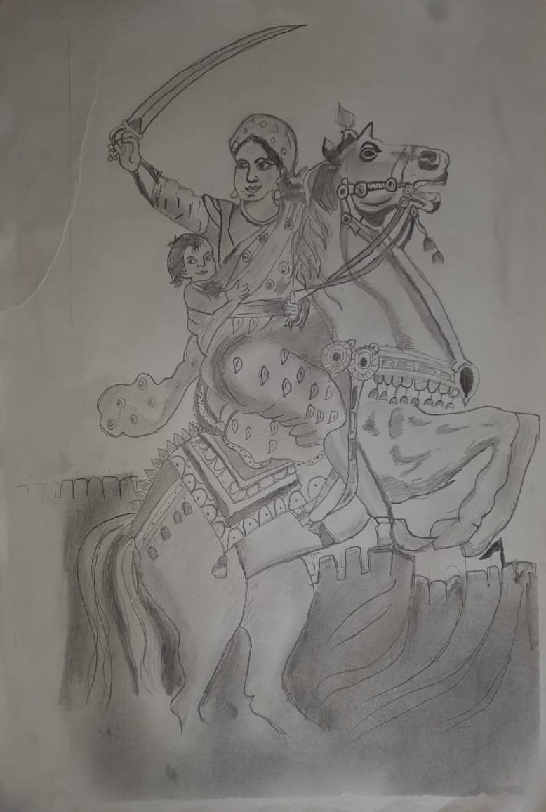

OBSERVANCE OF WORLD HEART DAY (SEPTEMBER 29,2023)
With the aim of spreading awareness about heart health and to promote a healthy lifestyle from a young age, World Heart Day was observed at APS Samba on September 29,2023.
On this occasion an interactive session on the theme "USE HEART FOR EVERY HEART" was organised for the students of class XI in the AV Room, where lifestyle disorders and ways to overcome them were discussed through a power point presentation as the modern lifestyle has emerged as a major reason for heart disease and failure.
The resource persons Ms Alka ( PGT Bio) and Ms Pallavi ( TGT Science) ended the session by showing a video on how to take care of our heart and keep it healthy.

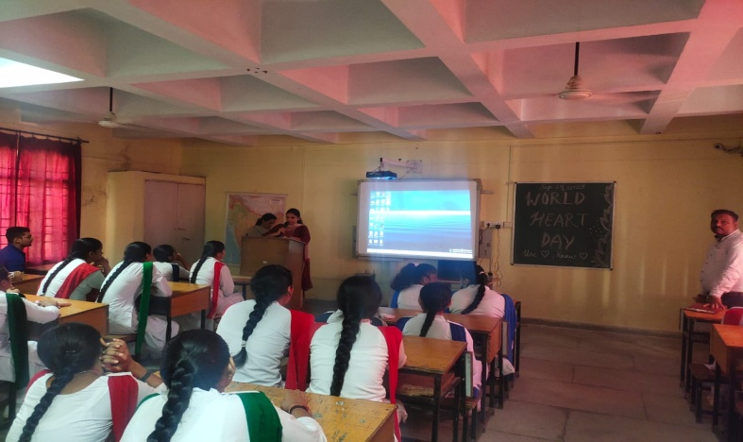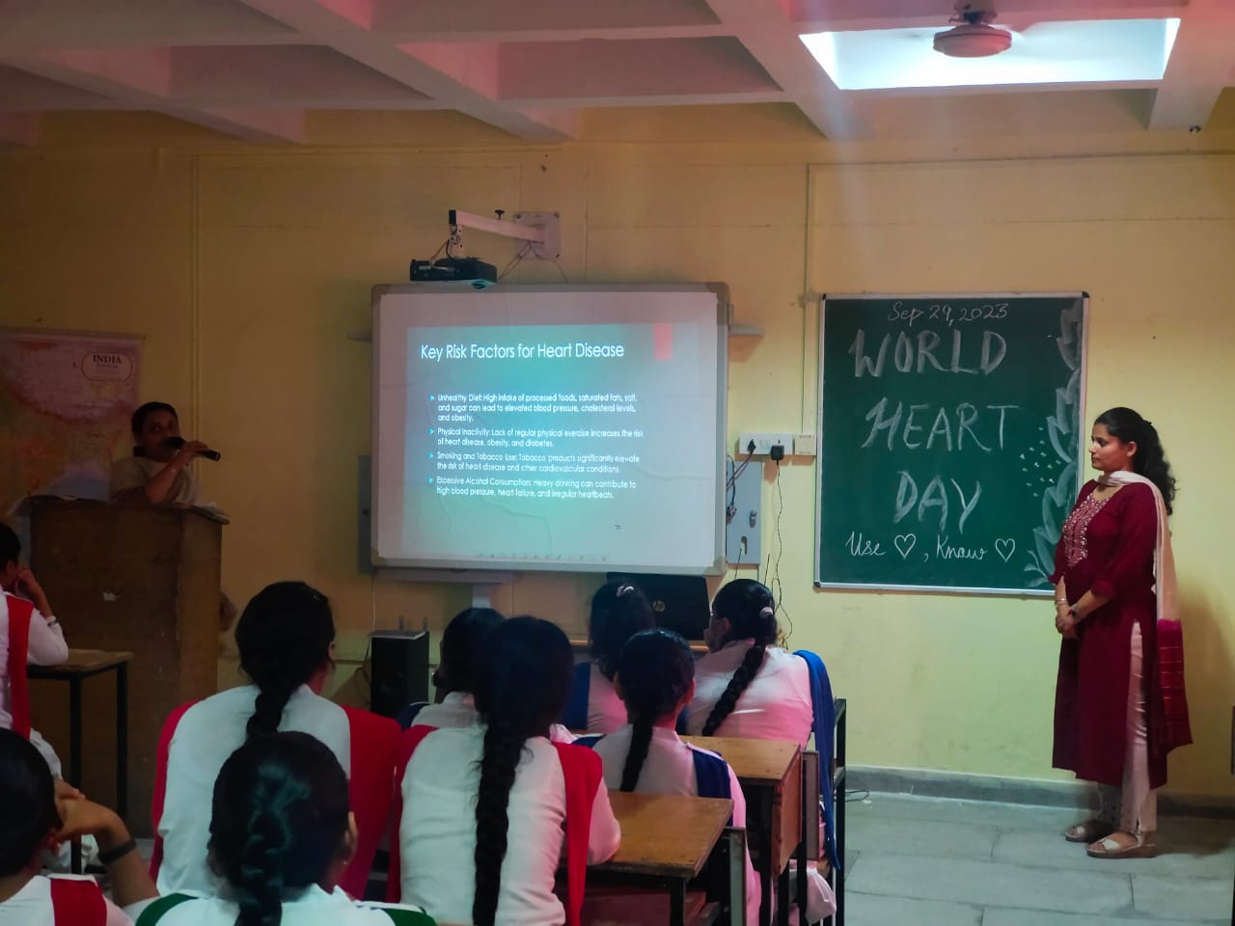

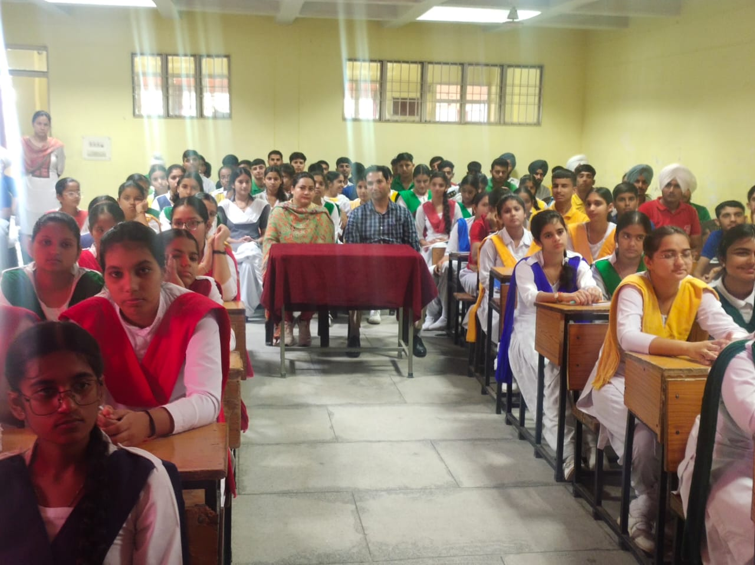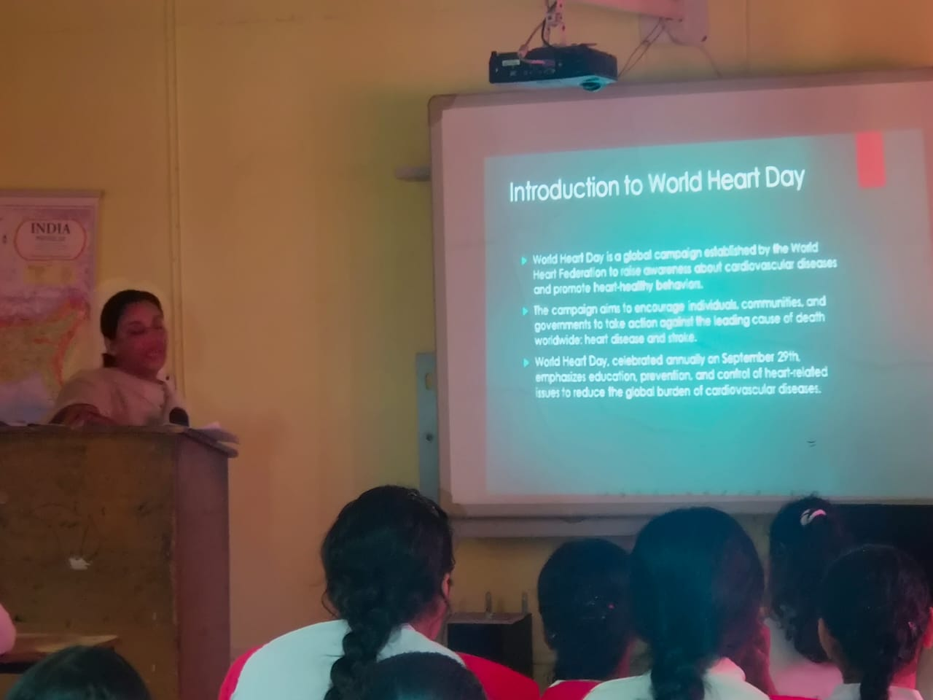

THANK YOU

